Suppose that you must design software that can be used by the patients to make an appointment with the doctor. The patient has to register themselves with all necessary information. They then search for the doctor. They have to select available slots for the selected doctor. They can also go back and change the doctor if slots are unavailable. The payment must be made before consultation. Then they must login at the appointment time and secure connection through VPN is established, the doctor treats them online.

Apply DECOMPOSITION to this problem and describe, in detail, at least THREE MAJOR ASPECTS of the problem that will help simplify providing a solution to this problem. Your answers should explore the topics in depth and not be trivial.

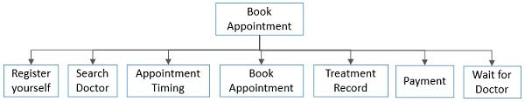

1. Payment and Treatment : Tasks: 1. Payment 2.Establish VPN connection 3. Talk to doctor
2. Register:Tasks:
3. Making appointments :Tasks

Simplify problem: 1.Error detection and correction

2. Privacy and Security

3. Can be effectively used with teams.

You are appointed to develop web application for Canadian blood services. You need keep track of the donors; it has various clinics for blood donation all over Canada. Web site checks the eligibility of a person to donate blood. It allows people to also shop for some merchandise. It also keeps track of employees. Describe, in detail, at least TWO DATA STRUCTURES that could be used in this application. How would the data structures you identified help with the solution of this problem?

Your answers should explore the topics in depth and not be trivial.

1.Donor: Donorid,name,address,email,phone, bloodgroup, weight,height, birthdate,year

2.

You need to create a web application that will allow patients to book both their Covid-19 vaccine and flu shot appointments. Describe, in detail, at least TWO MAJOR PARTS of this problem where you would have to apply PATTERN RECOGNITION. What patterns are revealed and how does this help in providing a better solution to this problem? Your answers should explore the topics in depth and not be trivial.

You need to create a web application that will allow patients to book both their Covid-19 vaccine and flu shot appointments. Describe, in detail, at least TWO DATA STRUCTURES that could be used in this application. How would the data structures you identified help with the solution of this problem? Your answers should explore the topics in depth and not be trivial.

The student can only view their grades but not those of any other students. Describe, in detail, how the abstraction would help with the solution of this problem. Your answers should explore the topics in depth and not be trivial.

The system should enable in-house traders to: Buy and sell stocks, Schedule trades, Issue report, Analyze the trades

The users of the system utilize a browser to connect to the system and manage connected sessions, completing a form and submitting the request. After a trade, report, or analysis request, the system sends an email to the users confirming their request or containing the results

The data should be stored in a local database.

Apply DECOMPOSITION to this problem and describe, in detail, at least THREE MAJOR ASPECTS of the problem that will help simplify providing a solution to this problem. Your answers should explore the topics in depth and not be trivial.

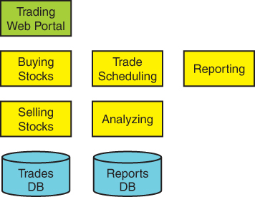

The coffee shop owner wants to learn about their customers. They want to know the hours when customers buy coffee more. Also, what are the hours when customers buy coffee and snacks together? The type of coffee that is bought by the customers is the most and the least favorite type. Describe, in detail, at least TWO DATA STRUCTURES that could be used in this application. How would the data structures you identified help with the solution of this problem? Your answers should explore the topics in depth and not be trivial.

Coffee->type

The coffee shop owner wants to learn about their customers. They want to know the hours when customers buy coffee more. Also, what are the hours when customers buy coffee and snacks together? The type of coffee that is bought by the customers is the most and the least favorite type. Describe, in detail, at least TWO MAJOR PARTS of this problem where you would have to apply PATTERN RECOGNITION. What patterns are revealed and how does this help in providing a better solution to this problem? Your answers should explore the topics in depth and not be trivial.

The Hamilton/Vinton Method sets the divisor as the proportion of the total population per house seat. After each state's population is divided by the divisor, the whole number of the quotient is kept and the fraction drops. This will result in surplus house seats. The first surplus seat is assigned to the state with the largest fraction after the original division. The next is assigned to the state with the second-largest fraction and so on. For example:

If a country had 4 states, and a 20-seat House of Representatives...

2560 + 3315 + 995 + 5012 = 11882

11882 ⁄ 20 = 594.1

State Population Quotient First Allocation of Seats Left Over Decimal Seats Apportioned

A 2560 2560 ⁄ 594.1 = 4.31 4 .31 4

B 3315 3315 ⁄ 594.1 = 5.58 5 .58 6

C 995 995 ⁄ 594.1 = 1.67 1 .67 2

D 5012 5012 ⁄ 594.1 = 8.44 8 .44 8

Total = 20 Seats

Apply DECOMPOSITION to this problem and describe, in detail, at least THREE MAJOR ASPECTS of the problem that will help simplify providing a solution to this problem. Your answers should explore the topics in depth and not be trivial.

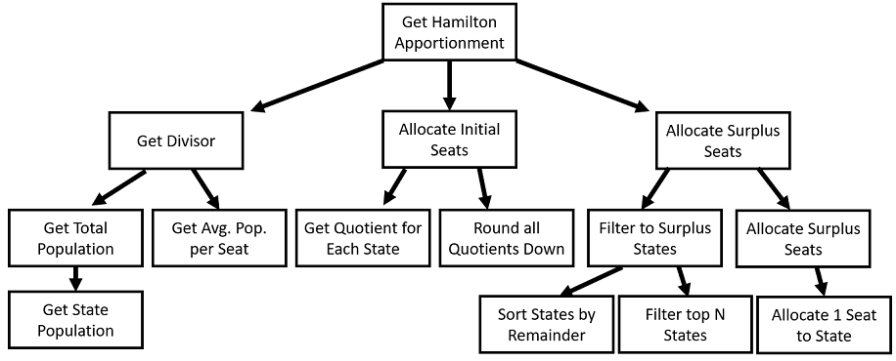

Processing an invoice is made up tasks receiving an invoice, extracting data from that invoice, getting approval for payment, processing payment. Apply DECOMPOSITION to this problem and describe, in detail, at least THREE MAJOR ASPECTS of the problem that will help simplify providing a solution to this problem. Your answers should explore the topics in depth and not be trivial.

Processing an invoice is made up tasks receiving an invoice, extracting data from that invoice, getting approval for payment, processing payment. Describe, in detail, at least TWO DATA STRUCTURES that could be used in this application. How would the data structures you identified help with the solution of this problem? Your answers should explore the topics in depth and not be trivial.

The insurance company installs the device in their customers’ cars. Initially, insurers had to rely on your driving record to understand your behind-the-wheel habits. Generally, they're looking for information that illustrates your usual driving habits, particularly habits that could lead to accidents or help you avoid them Typical data collected includes How often you drive and for how long, Hard braking, Hard acceleration, Speed, Fast cornering (quick, sharp turns), Time of day, especially nighttime driving, Phone usage while driving. Your insurer will use this data to set your rates, but the information collected can also be useful to you. Describe, in detail, at least TWO MAJOR PARTS of this problem where you would have to apply PATTERN RECOGNITION. What patterns are revealed and how does this help in providing a better solution to this problem? Your answers should explore the topics in depth and not be trivial.

The customer can only view their shopping cart but not that of any other . Describe, in detail, how the abstraction would help with the solution of this problem. Your answers should explore the topics in depth and not be trivial.

1. Explain what is abstraction?

2. How is abstraction applied here?

3. Why is abstraction used here?